|  |  |  |  |
| --- | --- | --- | --- |
| FULL NAME: | DATE: | CYCLE: | SPECIALTY: |

1. Choose the correct answer:

1. I ………………….. playing cricket.

񫘕 enjoy

󺏺 enjoying

2. She ……………………….. to wear expensive dresses.

򑽧 likes

𘒧 is liking

3. My sister ………………….. in Chennai.

򽸱 lives

𒿑 am living

4. She ………………………… the right person for this job.

𒿑 is

𒿑 are

5. Where ………………………. you live?

𒿑 does

𒿑 is

1. Complete

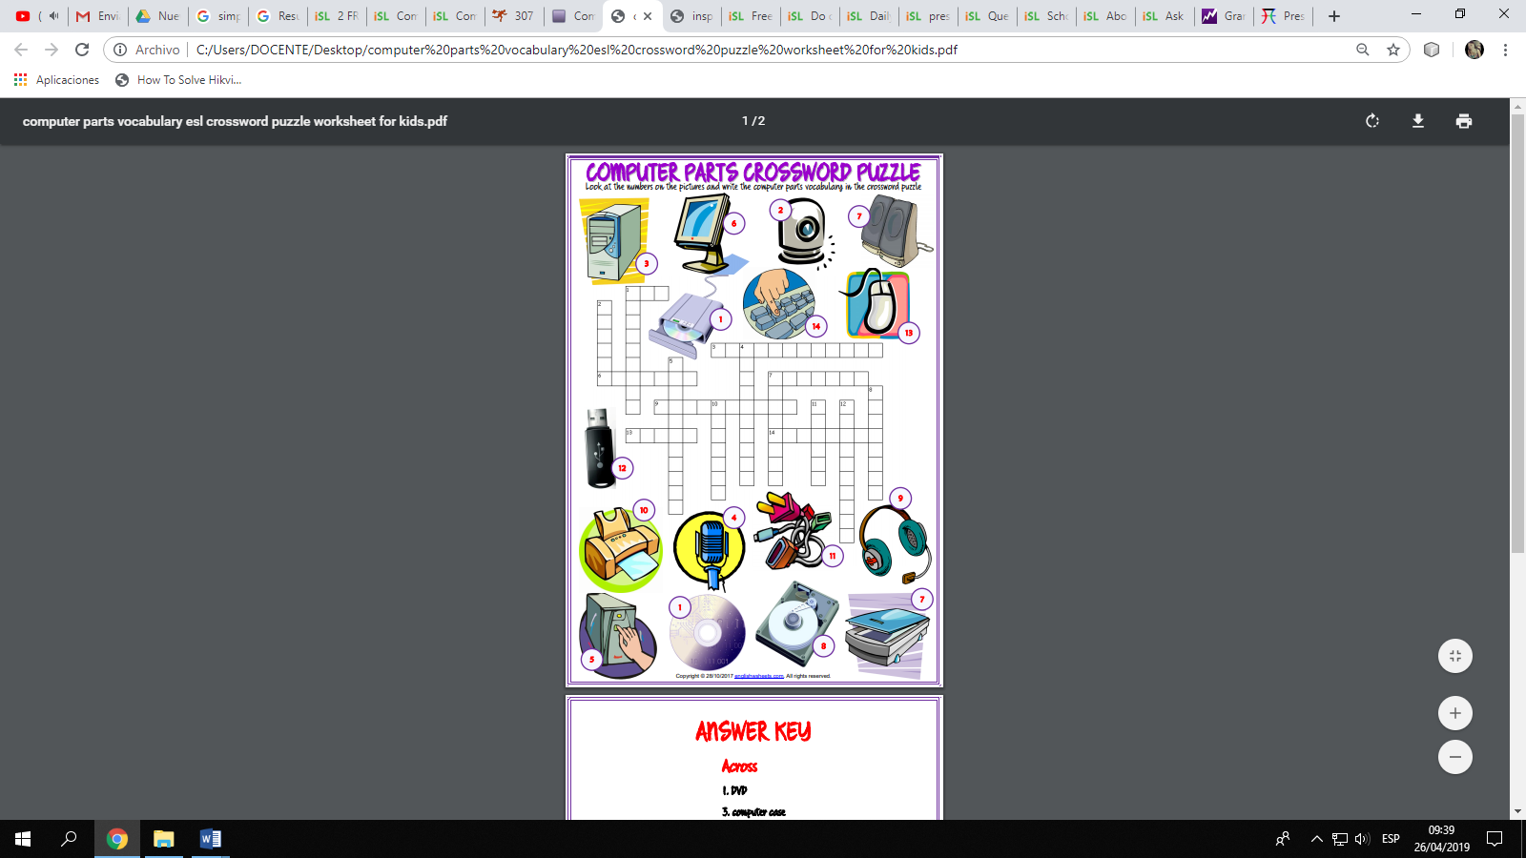

|  |  |  |  |
| --- | --- | --- | --- |
| FULL NAME: | DATE: | CYCLE: | SPECIALTY: |

1. Complete with Do or Does:
2. ____________he has any glue?
3. ____________they have any paint brushes?
4. ____________we have any paint?
5. ____________I have any string?
6. ____________my mother and sister have long hair?
7. ____________you have any popcorn?
8. ____________my father has any paper clips?
9. ____________my brother has any magnets?
10. ____________he has any crackers?
11. ____________I have any ribbon?
12. Arrange the words below to make questions.
13. she / to collect / stickers -
14. he / to read / books -
15. they / to play / a game -
16. the cat / to sleep / in the cat's bed -
17. she / often / to dream -
18. he / to play / streetball -
19. you / to be / from Paris -
20. the pupils / to wear / school uniforms -
21. you / to go / to the cinema -
22. she / to have / friends –

|  |  |  |  |
| --- | --- | --- | --- |
| FULL NAME: | DATE: | CYCLE: | SPECIALTY: |

* 1. Underline the correct answer:

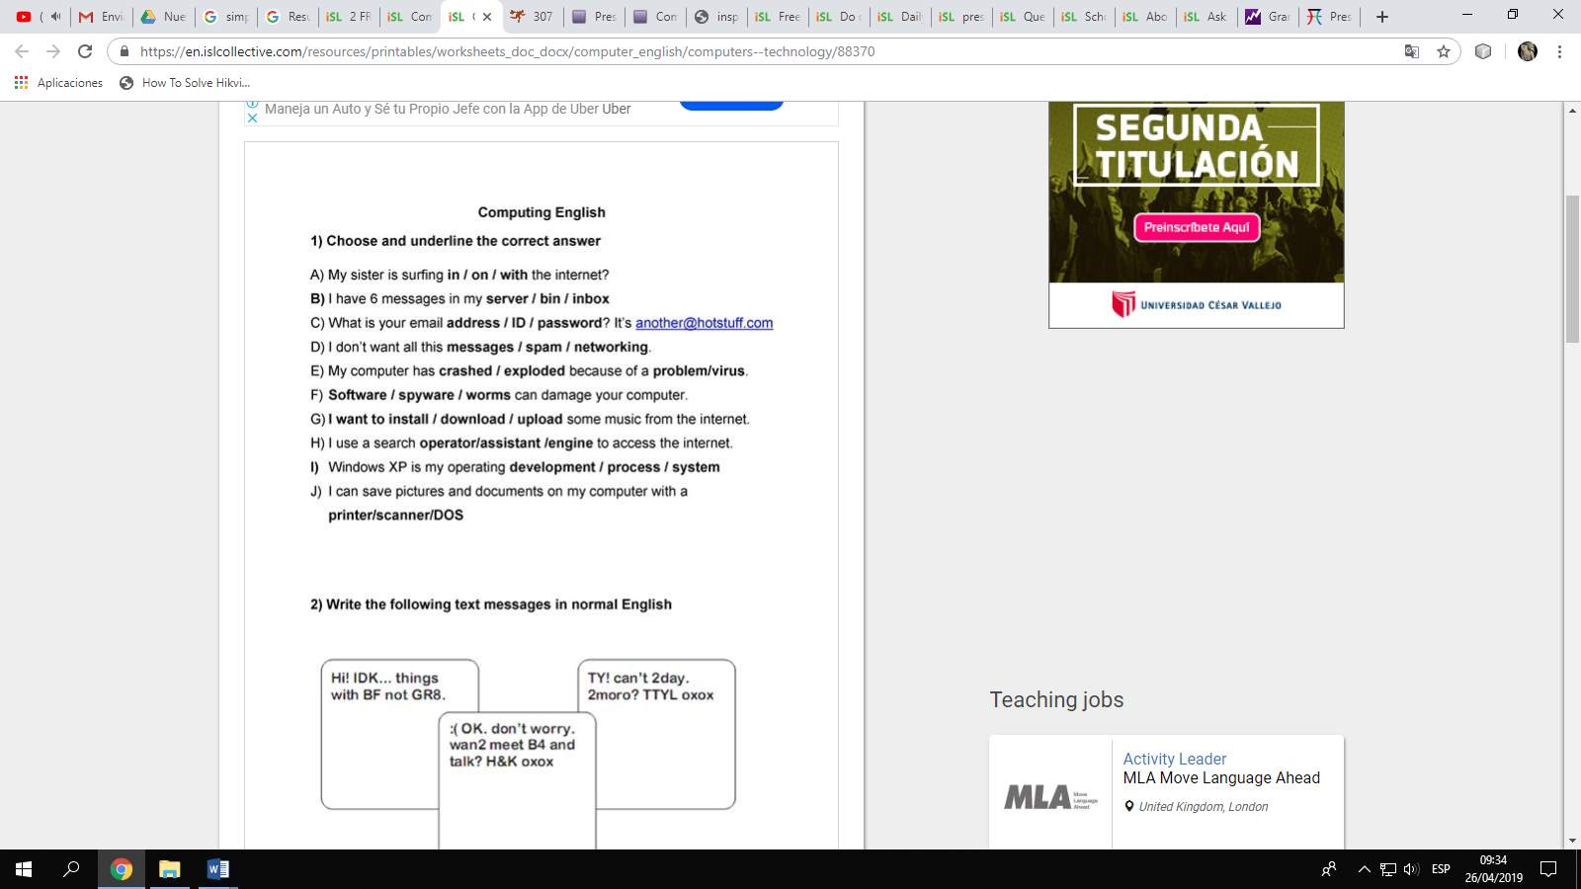**Computing**

* 1. Complete the sentences.

1. (your parents / work) in London?
2. How (I / do) this exercise?
3. (you / play) tennis every day?
4. (Delia / like) her new teacher?
5. Which school (they / go) to?
6. What time (Tim / get up) at the weekend?
7. (we / have) an English test today?
8. Who (you / walk) to school with?score

**VIDEO:**

<https://www.youtube.com/watch?v=FR4QIeZaPeM>